Award REcommendation
Notice of Intent to Award Number: 260000000427
Notice of Intent to Award Date: 4/27/2026
The Department of Natural Resources Procurement Office has completed the evaluation of RFQ 26*0194 – Mears State Park Sand Relocation and has recommended an award to Ken Adams Excavating in the amount of $15,515.00.

Participating bidders who were not recommended for award may schedule a debriefing session with the Solicitation Manager.

The debriefing session will provide the bidder with the State’s rationale on why the bidder was not recommended for the award. The Solicitation Manager may be contacted as follows:
Lisa Crozier-Green, Solicitation Manager.
CrozierGreenL@michigan.gov

Background Information:
This Request for Quotes (RFQ) was to solicit responses for selection of a Contractor to provide Sand Relocation at Mears State Park. This is a one-time purchase.
Bidders:
The RFQ was posted on SIGMA VSS on March 6, 2026, for a total of forty-nine calendar days. The following bidders submitted proposals by the published due date of April 24, 2026.
Bidder | Address, City, State, Zip Code | SDVOB* | GDBE**
Ken Adams Excavating | 8770 N. Oceana Drive, Pentwater, MI 49449 | NO | NO
KEO Rental & Service | 3601 County Rd. 612, NE, Kalkaska, MI 49646 | NO | NO
MECX, Inc. | 9079 Knight Road, Houston, TX 77054 | YES | NO
*SDVOB: Service-Disabled Veteran Owned Business
**GDBE: Geographically Disadvantaged Business Enterprise
Evaluation synopsis
- Evaluation Process
A Responsible Vendor is a vendor that demonstrates it can successfully perform the duties identified by the solicitation. A Responsive proposal is one that is submitted in accordance with the solicitation instructions and meets all mandatory requirements identified in the solicitation.
Proposal Instructions, Mandatory Minimum Requirements
PASS/FAIL – contract award to lowest price PASS bidder.
The full evaluation process is stated in the RFP Proposal Instructions.

- Evaluation Method
Responses to this solicitation were reviewed by the Solicitation Manager in collaboration with DNR Parks and Recreation Division Subject Matter Expert which consisted of the following individuals:
Lisa Crozier-Green, Solicitation Manager
Manny Valdez, DNR Parks and Recreation Division Subject Matter Expert
- Evaluation Results
The evaluators reviewed the proposals and made the following determinations related to the published specifications:
Specification | Ken Adams | KEO Rental | MECX, Inc.
Bid Package | PASS | PASS | PASS
Insurance Cert. | PASS | PASS | PASS
DETERMINATION | PASS | PASS | PASS

- Pricing Summary Pricing was evaluated for the bidders who received a PASS rating and is summarized below:
Deliverable | Ken Adams | KEO Rental | MECX, Inc.
Mears Sand Relocation | $15,515.00 | $29,340.00 | $35,900.00
Total Price | $15,515.00 | $29,340.00 | $35,900.00

- SDVOB Calculation
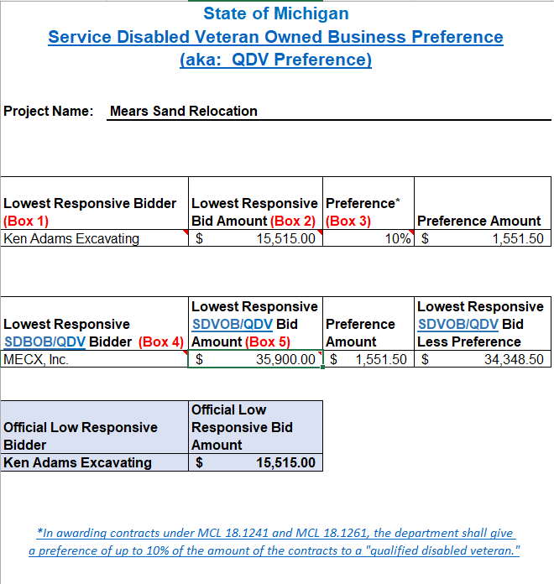
- Award Recommendation:
Award Recommendation is made to the responsive and responsible bidder who receives a PASS rating and offers the lowest price to the State of Michigan. Low price is determined by the bidder who meets the requirements and offers the lowest overall price as demonstrated by its proposal.

Award Recommendation is made to Ken Adams Excavating in the amount of $15,515.00.

